**Introduction**

Completed100 XP

* 2 minutes

Modern software systems running in the cloud are complex, and gaining visibility into the health and performance of your application-hosting environment across all of its layers of services is challenging. Fortunately, there are several solutions from Microsoft that can help you react quickly to outages, research intermittent issues, optimize your usage, and be proactive in handling future planned downtime.

Tailwind Traders, a traditional brick-and-mortar retailer, is now experiencing explosive growth by selling products online. The company is seeking to tighten and operationalize control of its cloud environment. It faces several challenges, from needing to optimize its cloud spend and security posture to tracking intermittent issues and planning ahead for upcoming outages. However, the company needs help with choosing the right product option for each of these scenarios.

In this module, you'll learn about the several Microsoft monitoring solutions, and you'll analyze decision criteria that experts use to select the right service for a specific scenario.

**Learning objectives**

After completing this module, you'll be able to:

* Choose the cloud monitoring service that best addresses your company's business challenges.

**Prerequisites**

* Familiarity with basic computing concepts and terminology
* Familiarity with cloud computing is helpful but not necessary

**Next unit: Identify your product options**

# Identify your product options

Completed100 XP

* 4 minutes

Several basic questions or concerns face all companies that use the cloud.

* Are we using the cloud correctly? Can we squeeze more performance out of our cloud spend?
* Are we spending more than we need to?
* Do we have our systems properly secured?
* How resilient are our resources? If we experience a regional outage, could we fail over to another region?
* How can we diagnose and fix issues that occur intermittently?
* How can we quickly determine the cause of an outage?
* How can we learn about planned downtime?

Fortunately, by using a combination of monitoring solutions on Azure, you can:

* Gain answers, insights, and alerts to help ensure that you've optimized your cloud usage.
* Ascertain the root cause of unplanned issues.
* Prepare ahead of time for planned outages.

## The product options

At a high level, there are three primary Azure monitoring offerings, each of which is aimed at a specific audience and use case and provides a diverse set of tools, services, programmatic APIs, and more.

<https://learn.microsoft.com/en-us/training/modules/monitoring-fundamentals/2-identify-product-options>

### Azure Advisor

[Azure Advisor](https://azure.microsoft.com/services/advisor/) evaluates your Azure resources and makes recommendations to help improve reliability, security, and performance, achieve operational excellence, and reduce costs. Advisor is designed to help you save time on cloud optimization. The recommendation service includes suggested actions you can take right away, postpone, or dismiss.

The recommendations are available via the Azure portal and the API, and you can set up notifications to alert you to new recommendations.

When you're in the Azure portal, the Advisor dashboard displays personalized recommendations for all your subscriptions, and you can use filters to select recommendations for specific subscriptions, resource groups, or services. The recommendations are divided into five categories:

* **Reliability**: Used to ensure and improve the continuity of your business-critical applications.
* **Security**: Used to detect threats and vulnerabilities that might lead to security breaches.
* **Performance**: Used to improve the speed of your applications.
* **Cost**: Used to optimize and reduce your overall Azure spending.
* **Operational Excellence**: Used to help you achieve process and workflow efficiency, resource manageability, and deployment best practices.

### Azure Monitor

[Azure Monitor](https://azure.microsoft.com/services/monitor/) is a platform for collecting, analyzing, visualizing, and potentially taking action based on the metric and logging data from your entire Azure and on-premises environment.

The following diagram illustrates just how comprehensive Azure Monitor is.

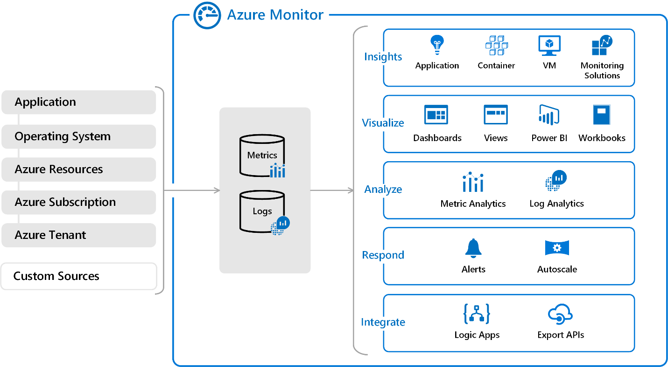

* On the left is a list of the sources of logging and metric data that can be collected at every layer in your application architecture, from application to operating system and network.
* In the center, you can see how the logging and metric data is stored in central repositories.
* On the right, the data is used in a number of ways. You can view real-time and historical performance across each layer of your architecture, or aggregated and detailed information. The data is displayed at different levels for different audiences. You can view high-level reports on the Azure Monitor Dashboard or create custom views by using Power BI and Kusto queries.

Additionally, you can use the data to help you react to critical events in real time, through alerts delivered to teams via SMS, email, and so on. Or you can use thresholds to trigger autoscaling functionality to scale up or down to meet the demand.

Some popular products such as Azure Application Insights, a service for sending telemetry information from application source code to Azure, uses Azure Monitor under the hood. With Application Insights, your application developers can take advantage of the powerful data-analysis platform in Azure Monitor to gain deep insights into an application's operations and diagnose errors without having to wait for users to report them.

### Azure Service Health

[Azure Service Health](https://azure.microsoft.com/features/service-health/) provides a personalized view of the health of the Azure services, regions, and resources you rely on. The status.azure.com website, which displays only major issues that broadly affect Azure customers, doesn't provide the full picture. But Azure Service Health displays both major and smaller, localized issues that affect you. Service issues are rare, but it's important to be prepared for the unexpected. You can set up alerts that help you triage outages and planned maintenance. After an outage, Service Health provides official incident reports, called root cause analyses (RCAs), which you can share with stakeholders.

Service Health helps you keep an eye on several event types:

* **Service issues** are problems in Azure, such as outages, that affect you right now. You can drill down to the affected services, regions, updates from your engineering teams, and find ways to share and track the latest information.
* **Planned maintenance** events can affect your availability. You can drill down to the affected services, regions, and details to show how an event will affect you and what you need to do. Most of these events occur without any impact to you and aren't shown here. In the rare case that a reboot is required, Service Health allows you to choose when to perform the maintenance to minimize the downtime.
* **Health advisories** are issues that require you to act to avoid service interruption, including service retirements and breaking changes. Health advisories are announced far in advance to allow you to plan.

## Next unit: Analyze the decision criteria

# Analyze the decision criteria

Completed100 XP

* 3 minutes

In this unit, you'll analyze the criteria that experts employ when they choose an Azure monitoring service for a specified business need. By understanding the criteria, you can better assess the nuanced differences among the products.

### Do you need to analyze how you're using Azure to reduce costs, improve resilience, or harden your security?

Choose Azure Advisor when you're looking for an analysis of your deployed resources. Azure Advisor analyzes the configuration and usage of your resources and provides suggestions on how to optimize for reliability, security, performance, costs, and operations based on experts' best practices.

### Do you want to monitor Azure services or your usage of Azure?

If you want to keep tabs on Azure itself, especially the services and regions you depend on, you want to choose Azure Service Health. You can view the current status of the Azure services you rely on, upcoming planned outages, and services that will be sunset. You can set up alerts that help you stay on top of incidents and upcoming downtime without having to visit the dashboard regularly.

However, if you want to keep track of the performance or issues related to your specific VM or container instances, databases, your applications, and so on, you want to visit Azure Monitor and create reports and notifications to help you understand how your services are performing or diagnose issues related to your Azure usage.

### Do you want to measure custom events alongside other usage metrics?

Choose Azure Monitor when you want to measure custom events alongside other collected telemetry data. Custom events, such as those added in the source code of your software applications, could help identify and diagnose why your application is behaving a certain way.

### Do you need to set up alerts for outages or when autoscaling is about to deploy new instances?

Here again, you would use Azure Monitor to set up alerts for key events that are related to your specific resources.

## Next unit: Use Azure Advisor

**Use Azure Advisor**

Completed100 XP

* 3 minutes

Tailwind Traders wants to optimize its cloud spend. Also, the organization is concerned about security breaches, because it stores customer data and historical purchase data in cloud-based databases. As the organization ramps up its cloud expertise, it wants to better understand its use of the cloud, better understand best practices, and pinpoint "easy wins" where it can tighten up its cloud spend and security practices.

**Which service should you choose?**

Apply the decision criteria you learned about in the preceding unit to find the right option.

First, in this scenario, does Tailwind Traders need to analyze its Azure usage for the sake of optimization? Yes. Tailwind Traders understands that it might be spending too much, is concerned about its security practices, and wants to have its cloud usage analyzed against industry best practices. Therefore, Azure Advisor is the perfect option for this scenario.

Although you might have found the right product option, let's continue evaluating the decision criteria for this scenario.

Second, in this scenario, does Tailwind Traders want to monitor the health of Azure services that affect all customers or the resources that are deployed on Azure? This scenario isn't concerned with operations. However, Azure Advisor does analyze and provide recommendations for achieving operational excellence.

Third, in this scenario, does Tailwind Traders want to measure custom events alongside other usage metrics? No, measuring custom events isn't mentioned as a requirement and isn't a consideration in this scenario.

Fourth, in this scenario, does Tailwind Traders want to set up alerts for outages or when autoscaling is about to deploy new instances? Again, this scenario isn't concerned with operations. However, Azure Advisor does analyze and provide recommendations for achieving operational excellence.

Azure Advisor is the right product option to help Tailwind Traders better understand and optimize both its cloud spend and its cloud security posture. This product might help the organization with other areas of its cloud usage as well.

**Next unit: Use Azure Monitor**

**Use Azure Monitor**

Completed100 XP

* 3 minutes

The Tailwind Traders e-commerce website is experiencing intermittent errors, and the team is unsure of the cause. Because of the nature of the errors, the team suspects that it's either a database or caching issue. What are the circumstances surrounding the errors? Does it happen only during peak usage times? What is the state of the team's Azure SQL instance? What is the state of its Redis caching server? How can it trace the issues to a root cause?

**Which service should you choose?**

As in the preceding unit, apply the decision criteria that you learned about earlier to find the right option.

First, in this scenario, does Tailwind Traders need an analysis of its Azure usage for the sake of optimization? No, optimization isn't the team's objective in this scenario, so Azure Advisor isn't a candidate.

Second, in this scenario, does Tailwind Traders want to monitor the health of Azure services that affect all customers or the resources deployed on Azure? Because this issue happens intermittently, it's unlikely to affect an entire Azure region or service. It's more likely that a logic issue exists somewhere in their e-commerce website code, or another issue is causing database failures or caching locks. In this scenario, the team could use Azure Monitor to pinpoint a specific user session and look at the performance of each service that's involved in the issue.

Third, in this scenario, does Tailwind Traders want to measure custom events alongside other usage metrics? Yes. Software developers can send additional information about the state of the web application via Application Insights to help locate the root cause of the issue. Application Insights relies on the Azure Monitor platform to store custom event information.

Fourth, in this scenario, does Tailwind Traders want to set up alerts for outages or for when autoscaling is about to deploy new instances? No, alerting isn't their objective in this scenario.

Azure Monitor is the best option for helping Tailwind Traders track this intermittent issue. The team can use a wealth of tools to help it gain insight into the application's performance at a high level and dive deep into specific issues.

**Next unit: Use Azure Service Health**

**Use Azure Service Health**

Completed100 XP

* 3 minutes

Tailwind Traders wants to operationalize its cloud environment. Specifically, its cloud operations team wants to let stakeholders know about upcoming planned downtime in advance. The team also wants its solution architects to be forewarned about any Microsoft plans to sunset services so it can rearchitect its software products accordingly.

When outages do happen, the team wants to quickly ascertain whether the issue is specific to their services or a service interruption that affects many Azure customers. The team also wants to provide key stakeholders with reports that explain how and why the incident occurred, and so on.

**Which service should you choose?**

Again, apply the decision criteria you learned about earlier to find the right product.

First, in this scenario, does Tailwind Traders need to analyze its Azure usage for the sake of optimization? No, so Azure Advisor isn't a candidate for this scenario.

Second, does Tailwind Traders want to monitor the health of Azure services that affect all customers or the resources deployed on Azure? In this scenario, the requirement is to stay abreast of upcoming planned downtime. Additionally, the team wants to capture official incident reports. For this reason, Azure Service Health is the strongest candidate to choose for this scenario.

Although it's likely that you would choose Azure Service Health, let's continue evaluating the remaining decision criteria.

Third, in this scenario, does Tailwind Traders want to measure custom events alongside other usage metrics? No, measuring custom events isn't mentioned as a requirement and isn't a consideration in this scenario.

Fourth, in this scenario, does Tailwind Traders want to set up alerts for outages or when autoscaling is about to deploy new instances? Setting up alerts for outages is a requirement in this scenario, but creating alerts for other events such as autoscaling are not in scope. Use Azure Service Health to set up alerts that are specific to Azure outages that affect all Azure customers. Use Azure Monitor to set up alerts for outages and other events that affect only your specific resources.

In this scenario, Azure Service Health is the correct option to choose.

**Next unit: Knowledge check**

**Knowledge check**

Completed200 XP

* 3 minutes

**Check your knowledge**

Top of Form

**1.**

You want to be alerted when new recommendations to improve your cloud environment are available. Which service will do this?



Azure Advisor

**Azure Advisor can alert you when new recommendations are available.**



Azure Monitor



Azure Service Health

**2.**

Which service provides official outage root cause analyses (RCAs) for Azure incidents?



Azure Advisor



Azure Monitor



Azure Service Health

**Azure Service Health provides incident history and RCAs to share with your stakeholders.**

**3.**

Which service is a platform that powers Application Insights, monitoring for VMs, containers, and Kubernetes?



Azure Advisor



Azure Monitor

**Azure Monitor is the platform used by Application Insights.**



Azure Service Health

Bottom of Form

**Next unit: Summary**

**Summary**

Completed100 XP

* 1 minute

Our goal in this module was to help Tailwind Traders explore several monitoring service offerings from Azure to apply to a variety of business scenarios.

We identified three product options and their capabilities: Azure Advisor, Azure Monitor, and Azure Service Health. We analyzed decision criteria for choosing one option over another for certain scenarios. Then we applied those decision criteria to three different challenges faced by Tailwind Traders, helping them find the best service option for the scenario.

Without monitoring services, Tailwind Traders would spend more money on its cloud environment, be unsure about its cloud security posture, have difficulty pinpointing issues in its application logic, and be unable to plan ahead for outages or supply formal outage reports to stakeholders.

Azure monitoring services provide a comprehensive array of features to help improve your cloud operations.

**Module complete:**